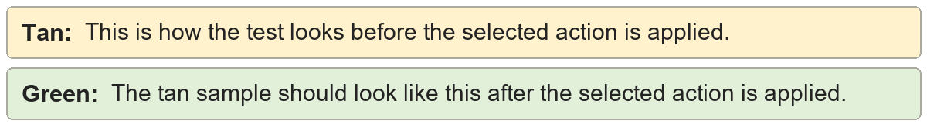
Curly double quotes | “Quoted words remain readable.”
Curly double quotes | "Quoted words remain readable."

Curly single quotes | It’s copied from Word’s editor.
Curly single quotes | It's copied from Word's editor.

Em dashes | A pause—then the sentence continues.
Em dashes | A pause-then the sentence continues.

En dashes | Pages 10–15 contain the example.
En dashes | Pages 10-15 contain the example.

Ellipses | Wait…the sentence continues.
Ellipses | Wait...the sentence continues.

